23.45: a) 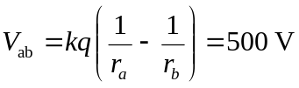
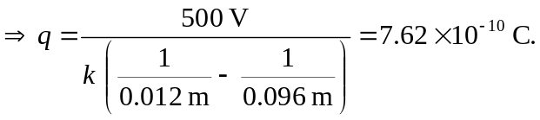

b)
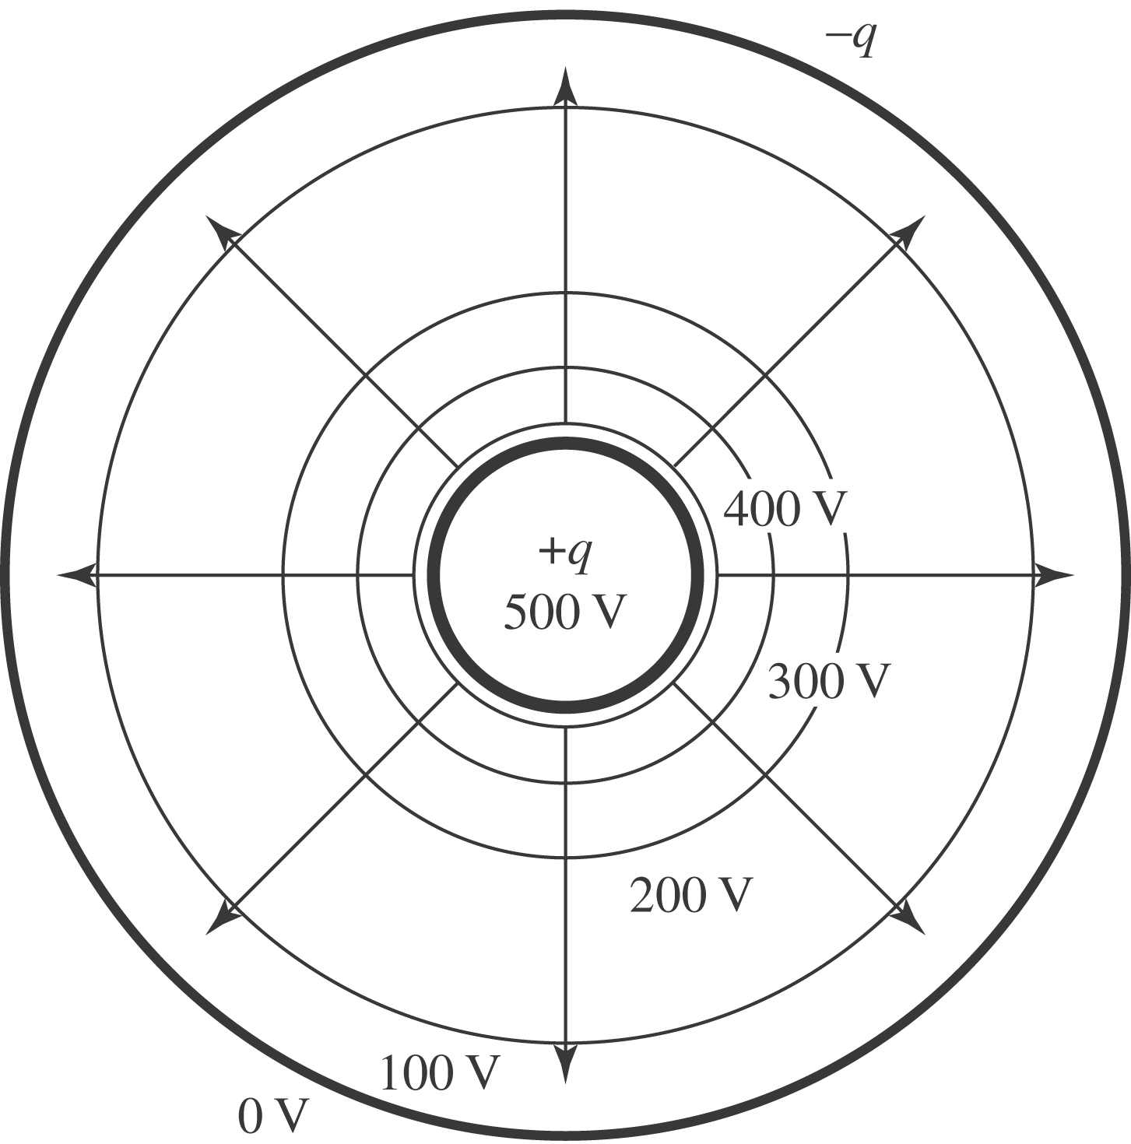

c) The equipotentials are closest when the electric field is largest.

